package employee;
import java.sql.*;
import java.util.Scanner;
public class employee {

public static void main(String[] args) throws Exception
{

Class.forName("com.mysql.cj.jdbc.Driver");

Connection con=DriverManager.getConnection("jdbc:mysql://localhost/SJDBC", "root", "root");

PreparedStatement pt =con.prepareStatement("INSERT INTO employee VALUES(?,?,?,?)");

try (Scanner sc = new Scanner(System.in)) {
System.out.println("Enter employee id:");
String e_id=sc.next();

System.out.println("Enter employee Name:");
String e_name=sc.next();

System.out.println("Enter employee salary:");
int e_sal=sc.nextInt();

System.out.println("Enter employee city:");
String e_city=sc.next();

pt.setString(1, e_id);
pt.setString(2, e_name);
pt.setLong(3, e_sal);
pt.setString(4, e_city);

}
int r=pt.executeUpdate();
con.close();
System.out.println(r+"record added successfully!!!");

}

}

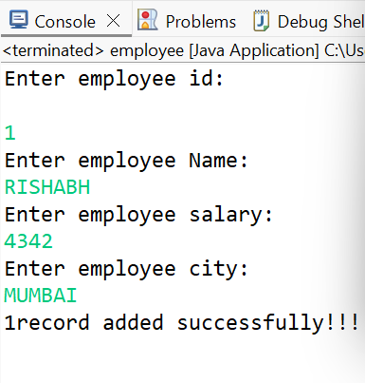

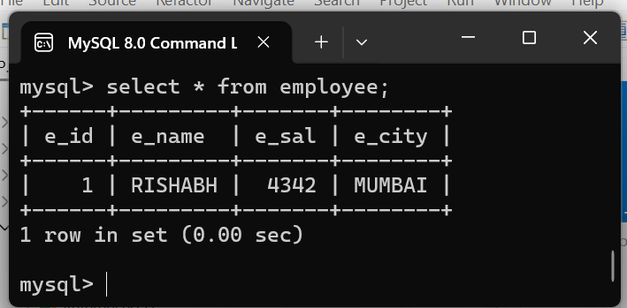

package customer;

import java.sql.*;

public class customer {
public static void main(String[] args) throws Exception
{
// TODO Auto-generated method stub

Class.forName("com.mysql.cj.jdbc.Driver");

//Connection con=DriverManager.getConnection("jdbc:mysql://localhost/CustData", "root", "newpass");
Connection con=DriverManager.getConnection("jdbc:mysql://localhost/SJDBC", "root", "root");

/*
* UPDATE Employee SET Sal = 35555, WHERE id = 2; delete from employee where
* id=3;
*/

PreparedStatement pstmt=con.prepareStatement("INSERT INTO customer VALUES(?,?,?,?)");

Statement st = con.createStatement();
ResultSet rs = st.executeQuery("select * from customer");
int sal,id;
String name , desig ;
System.out.println("Customer Details");
System.out.println("===============================================================");
while(rs.next())
{
id=rs.getInt(1);
name=rs.getString(2);
desig=rs.getString(3);
sal= rs.getInt(4);
System.out.println(id+" | "+name+" | "+desig+" | "+sal );

}
con.close();

}

}

